Application Development
ENHANCED PROFESSIONAL STUDENT LOGBOOK
Student Name : CHRISTOPHER MUSILA
Admission Number: BIT/2024/59761
School/Faculty: Computing And Informatics
Programme: Bachelor of Information Technology
Academic Year: Year 3
Semester: 2ND
Lecture: Michael Nyoro
Phone Number: 0714474754

Week 1: Introduction To Mobile Application Development
Practical Activities Undertaken:
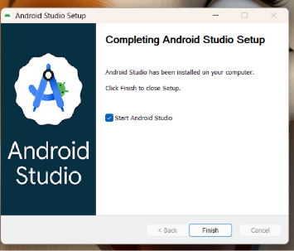
Figure 1.1: Android Studio Setup
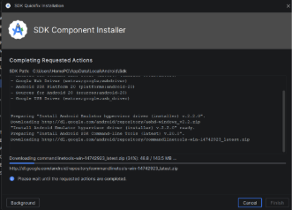
Figure1.2: SDK platforms build
Downloaded the Flutter SDK and initialized the Android Studio installation package. Worked through the initial IDE setup wizards, configured basic SDK command-line dependencies, and mapped out the initial project folders for the upcoming application.
Tools/Software Used:
Android studio installer, flutter SDK, windows file explorer.
Personal Reflection:
During the first week of developing my Flutter Student Management System, I focused on setting up the development environment, understanding the project requirements, and creating the basic structure of the application. I successfully installed and configured Flutter, Android Studio, and other necessary tools, which enabled me to begin designing the user interface. I worked on developing initial screens and explored Flutter widgets, navigation, and layout design. I also started learning how Firebase can be integrated into the project for data storage and management.

Week 2: Mobile Development Environment
Practical Activities Undertaken:
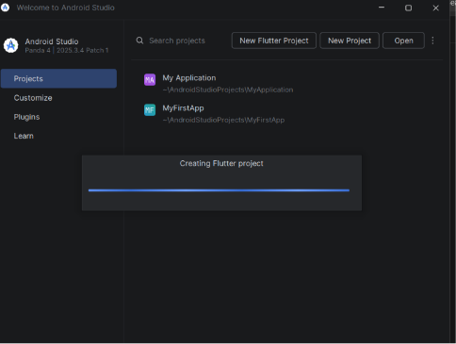
Figure 1.3: Generating flutter framework
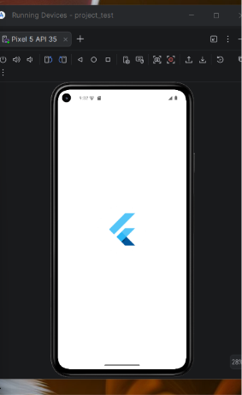
Figure 1.4: Generated flutter project inside Android studio
I set up Environmental system variables to connect the Flutter SDK worldwide. created and initialized the AfyaFlow project repository template in Android Studio. reviewed the project architecture files that were automatically generated, made changes to the baseline main.dart script to create a clean environment, and successfully ran a test run on the target virtual device emulator to confirm that the template application compiled error-free.Tools/Software Used:
Android Studio IDE, Flutter SDK, Dart SDK, Command Prompt terminal, Android Virtual Device (AVD) emulator.
Personal Reflection:
During the second week of developing my Flutter Student Management System, I concentrated on implementing the core functionalities of the application. I designed and developed features for adding, viewing, editing, and deleting student records while improving the overall user interface for better usability. I also worked on integrating Firebase services .
Week 3: User Interface Design
Practical Activities Undertaken:
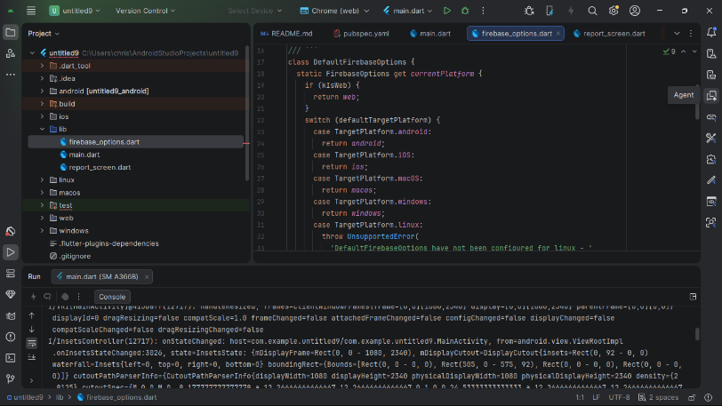
Figure 1.5: Patient screen and GUI
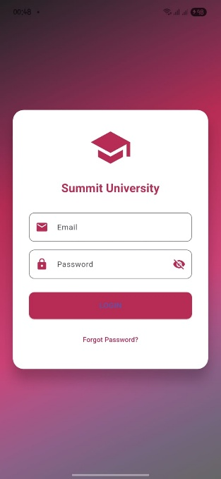
Figure 1.6: Finalized user interface
Designed and developed the user interface for the core application authentication layout, focusing specifically on the Student Login Screen. Built out the form containers using text fields for input values, designed submission button states, and managed custom interface spacing properties within a newly structured screens folder directory to handle presentation views separately from core logic files.

Tools/Software Used:
Android Studio, Flutter Framework, Dart Layout Widgets (Column, TextField, ElevatedButton).

Personal Reflection:
During the third week of developing my Flutter Student Management System, I focused on enhancing the application's features and improving its performance. I implemented additional functionalities such as student search, report generation, and data validation to ensure accurate record management. I also refined the user interface by improving navigation, layouts, and responsiveness across different screen sizes. Extensive testing was conducted to identify and fix bugs, ensuring that the system operated smoothly and efficiently.

Week 4:
Practical Activities Undertaken:
Designing a good UI with functional screens
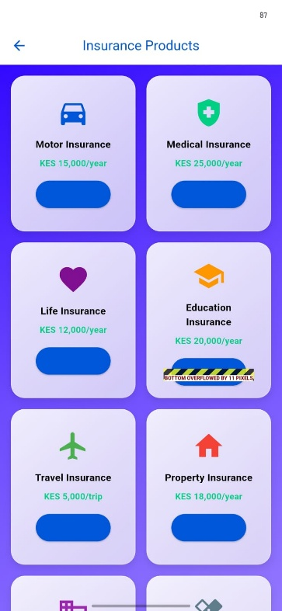
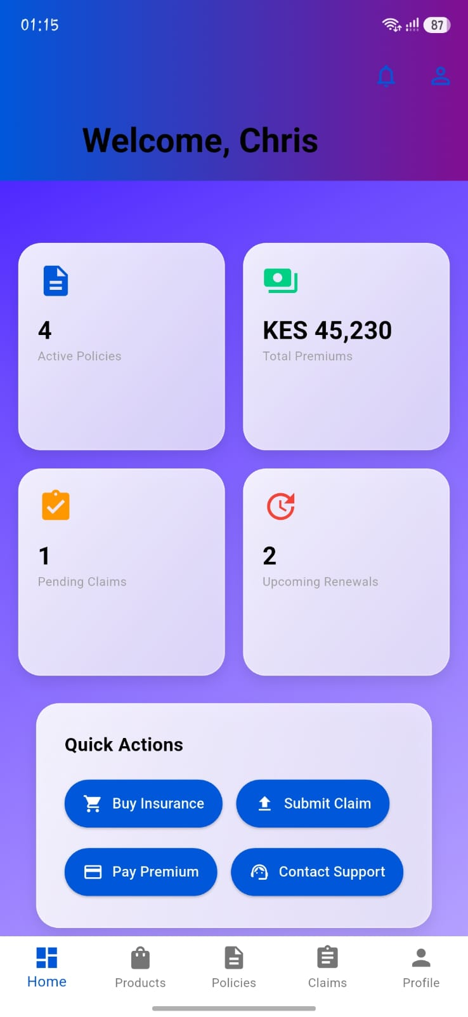Dashboard

PERSONAL REFLECTION:
I continued improving my Flutter development skills by focusing on user interface design, navigation, and application structure. I learned how to create more professional-looking screens using modern design principles and reusable widgets. I also gained experience organizing project files using a clean architecture approach, which made the code easier to manage and maintain.

Week 5
Practical Activities Undertaken:
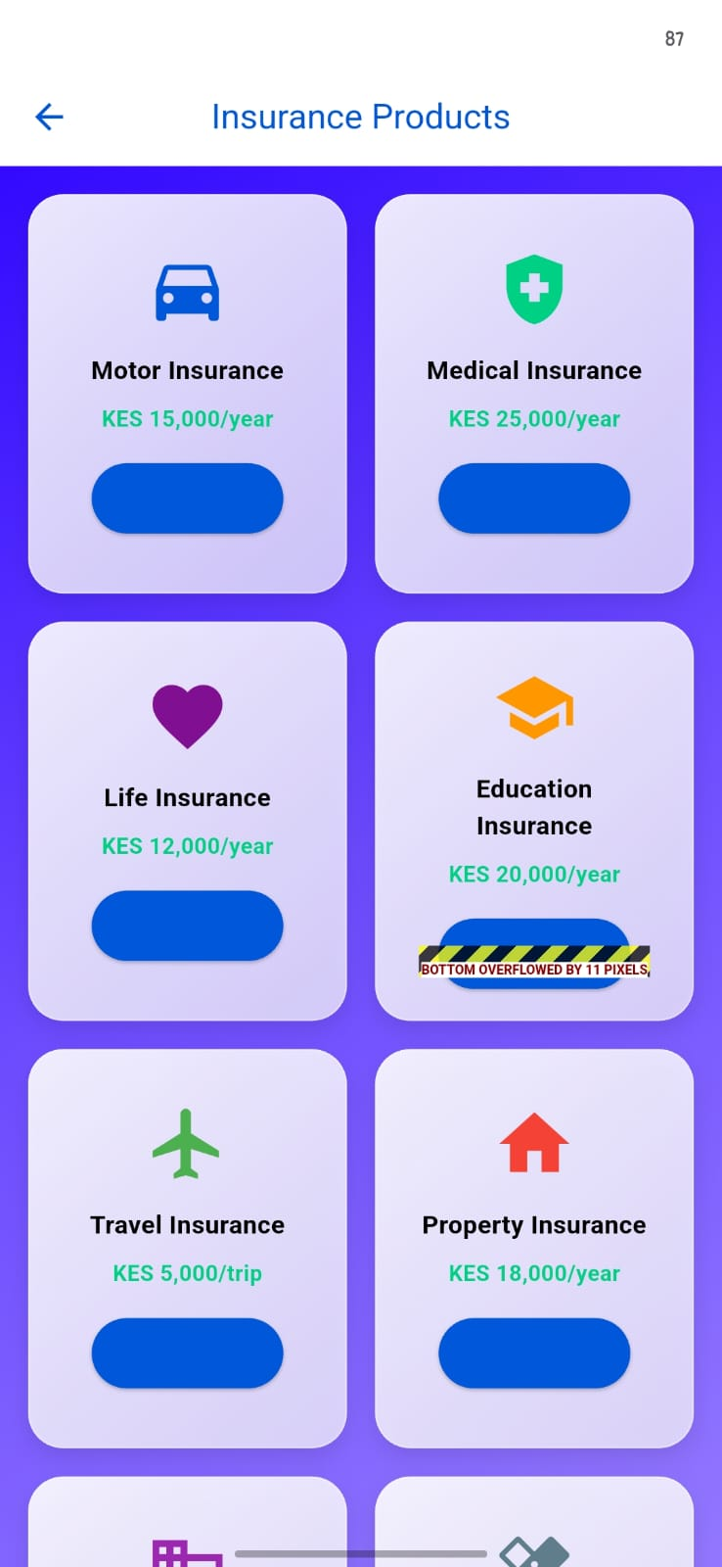

Applied CRUD to my project where I can create, read, update and delete
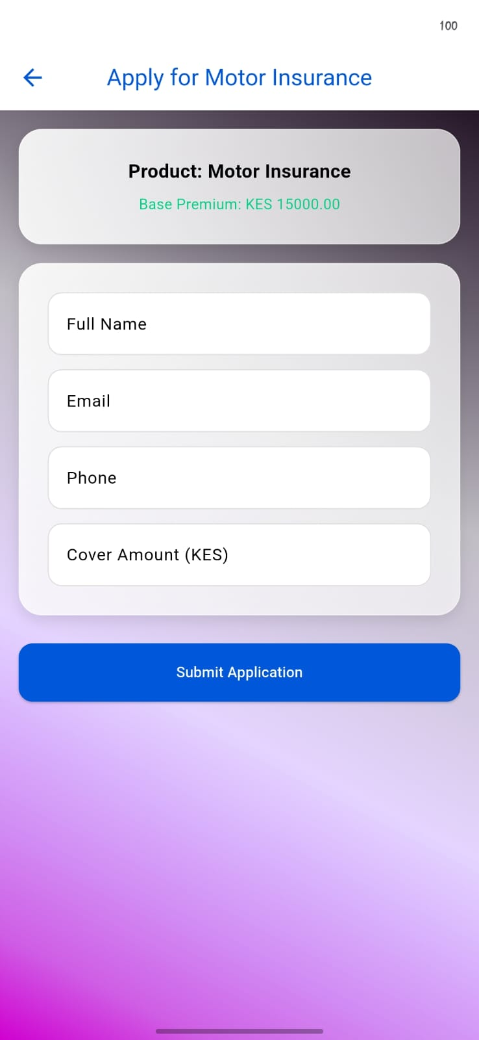

Connected firebase authentication to the login page
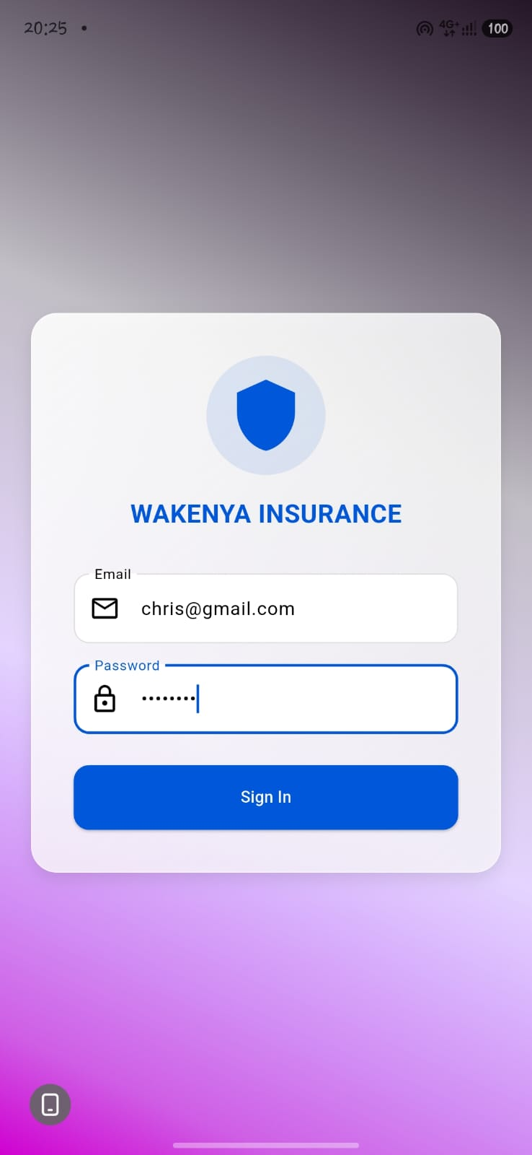

PERSONAL REFLECTION:
Week 5 introduced me to Firebase Authentication and CRUD operations, where I learned to implement secure user login and build create, read, update, and delete functions for cloud data. The biggest challenge was mastering asynchronous JavaScript with async/await to properly handle database calls without triggering undefined errors, but once I got it working and saw my data persist across browser refreshes, everything finally clicked into place.

WEEK 6
I connected the project to network and APIs
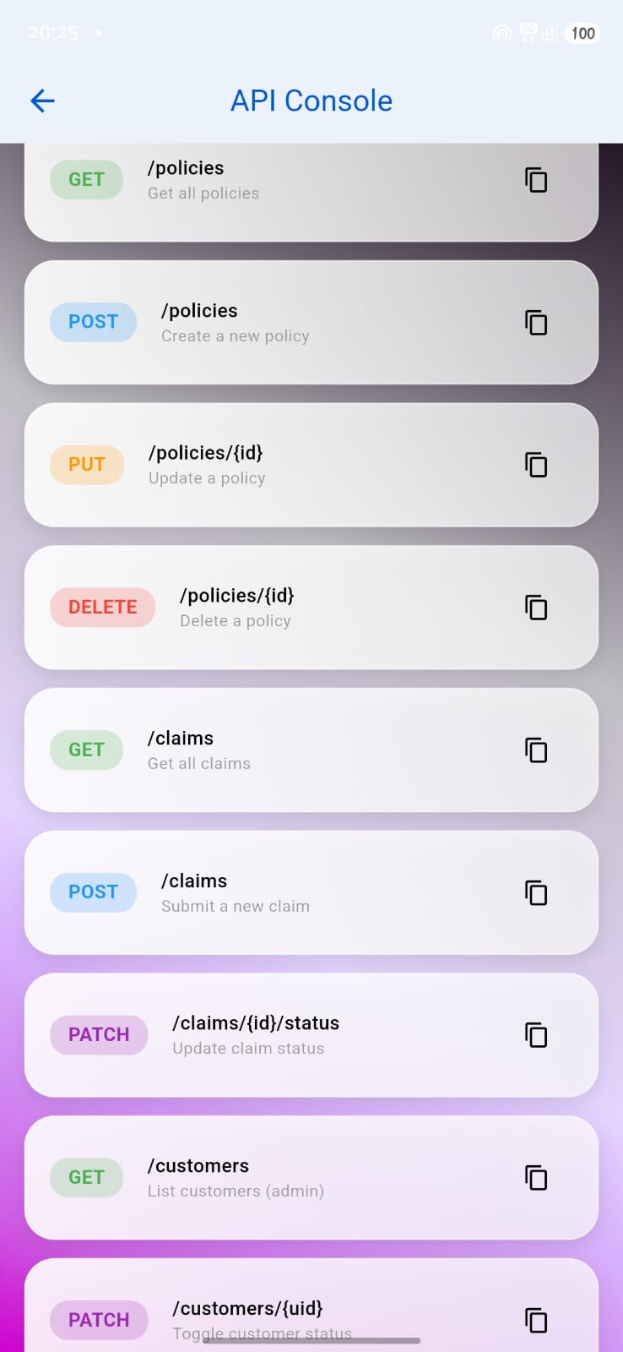

I also connected to chatbox with AI
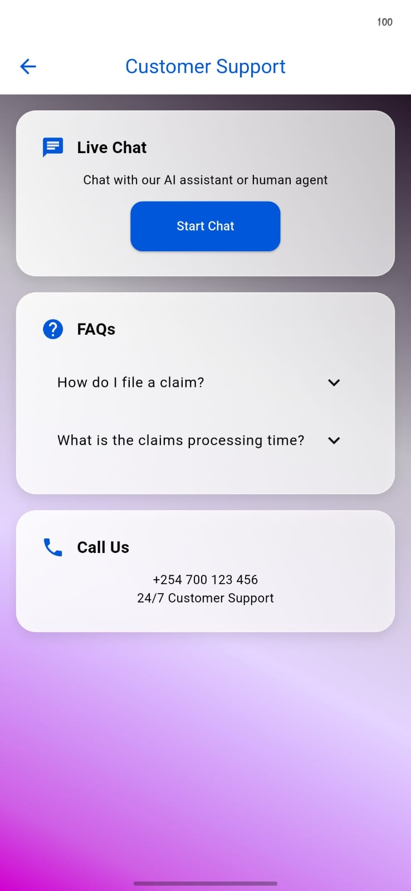
PERSONAL REFLECTION:
Building the chat application in week 6 combined networking APIs with real-time Firestore listeners, requiring me to manage live message streams, proper data structuring with timestamps, and responsive UI state management. The most valuable lesson was understanding how to trigger efficient re-renders while handling network latency, and seeing my fully functional chat interface come together made me appreciate how authentication, databases, and real-time communication connect in practical applications.

